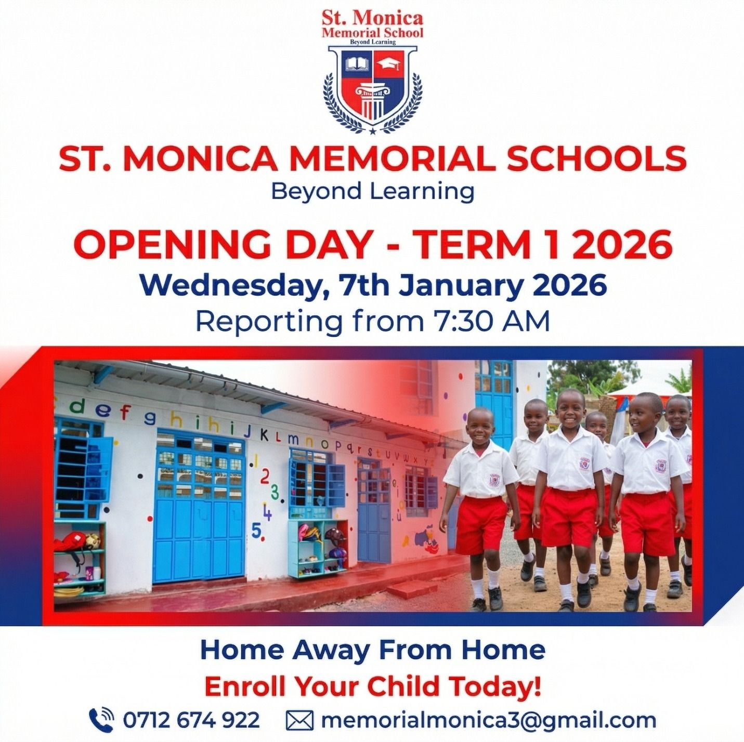
Co-curricular & Extra Curricular Policy

St. Monica School’s co-curricular and extra-curricular policy is in full accordance with its Code of Behavior, promoting positive relationships between students and between students and teachers in a safe and just environment through participation in school-organized activities.

Teachers involved in extra-curricular or co-curricular activities should aim to interact positively with students, enhancing their involvement, enjoyment, and welfare. This policy facilitates these aims and protects teachers in their various roles by providing a framework for good practice.

Guidelines for Teachers

- Safety and Supervision: The primary focus is student safety and enjoyment. Proper levels of supervision must take place at all times.
- Focus on Enjoyment: Enjoyment of the activity should not depend solely on performance levels or competition outcomes.
- Role and Responsibilities: Teacher-coaches should work in a safe environment and maintain clear knowledge of their roles and responsibilities.
- Professional Boundaries: Teacher-coaches are responsible for establishing clear boundaries between a professional working relationship and friendship with participating students.
- Code of Behavior: Teachers should operate according to the school's code of behavior, emphasizing good behavior, mutual respect, adherence to rules, responsibility, and fair play.
- Parental Respect & Communication: Parents and guardians should show respect for the teacher-coach and inform them of any special needs of the child.
- Safety and Welfare Promotion: To promote student and personal safety, teachers should:
  - Be positive, praising and encouraging effort as well as results.
  - Prioritize student welfare and safety above all else.
  - Possess relevant knowledge and experience for working with young people.
  - Avoid overtraining and overemphasizing winning.
  - Avoid situations where they are alone with students away from others or transporting single students in their personal cars.
  - Refrain from using alcohol, cigarettes, and drugs during events or on trips.
  - Avoid foul language, aggressive behavior, or physical force toward students.
  - Conduct 'hands-on' coaching only in an open, appropriate manner with full knowledge, permission, and understanding of participants (and parents/guardians where necessary).
  - Avoid fitness testing without another adult present.
  - Avoid conducting any form of therapy (e.g., hypnosis) during training.

- Equipment & Facility Safety: Conduct regular safety checks on premises, training facilities, and equipment. Goalposts, in particular, should be checked regularly, and self-standing goals must be secured to acceptable safety standards.
  - A first aid kit must be available at all training sessions and matches.
  - Record injuries with a note of action taken for each instance.
  - Injured players must not participate, regardless of the competition's importance.
  - Parents or guardians must be notified of any injuries or illnesses incurred during an activity.
- Student Entitlements: Students participating in sports or activities are entitled to:
  - Be safe.
  - Be treated with care, sensitivity, and respect.
  - Have fun and enjoy the activity.
  - File complaints in an appropriate manner and have them addressed through fair, proper procedures.
  - Be listened to and believed.
- Student Responsibilities: Participating students should:
  - Play fairly.
  - Respect opponents and teammates.
  - Be modest in victory and gracious in defeat.
  - Avoid cheating, abusive language, or arguing with referees, teammates, or opponents.
  - Refrain from spreading falsehoods about adults or peers.
  - Avoid using banned substances to enhance performance.
  - Refrain from keeping secrets about anyone who may have caused them harm.
  - Ensure participation does not negatively affect academic progress by keeping up with classwork and homework.

Note on Child Protection: Under child protection procedures, any person with concerns regarding a child's welfare or who suspects abuse must report these concerns to the school's Designated Liaison Person (DLP).

Guidelines for Educational Tours

- Approval: Educational tour plans must receive approval from the school principal.
- Itinerary & Tour Details: Full itinerary and tour details must be provided to the school principal, the Director, and parents/guardians of participating students. The itinerary must list names, addresses, and phone numbers of hotels or accommodation facilities where the group will stay.
- Insurance: Medical and personal accident insurance must be provided as an integral component of the total tour cost.
- Rules & Expectations: Students must be fully briefed on appropriate rules, regulations, and expected standards of behavior while on tour. Breaches will incur sanctions per the school's Code of Behavior.
- Emergency Procedures: Clear guidelines must be provided in advance regarding steps to take if a student is separated from the group or encounters another emergency.
- Staffing Ratios: A sufficient number of full-time teaching staff must accompany the students. Mixed-gender groups require an appropriate balance of male and female staff.

- Contact Information: Each student must have the contact phone number of the group leader while on tour.
- Emergency Protocol: In an emergency, the group leader must ensure:
  - The needs of affected students are met.
  - Parents/guardians of affected students are contacted.
  - The welfare and safety of remaining students are maintained.
  - Sufficient staff remain with both affected students and the rest of the group.
  - Contact is established with the Principal, Deputy Principal, or a member of the school's Critical Incident Team.
  - Liaison is established with regional/country medical teams and parents/guardians as required.

Overall Principle: Student health, safety, and general welfare remain the primary concern of all teachers and must inform all decisions made regarding students.

